1. Run Session tpisg0412.
2. Enter Project and click on Print.
3. Choose Report Type and click OK.

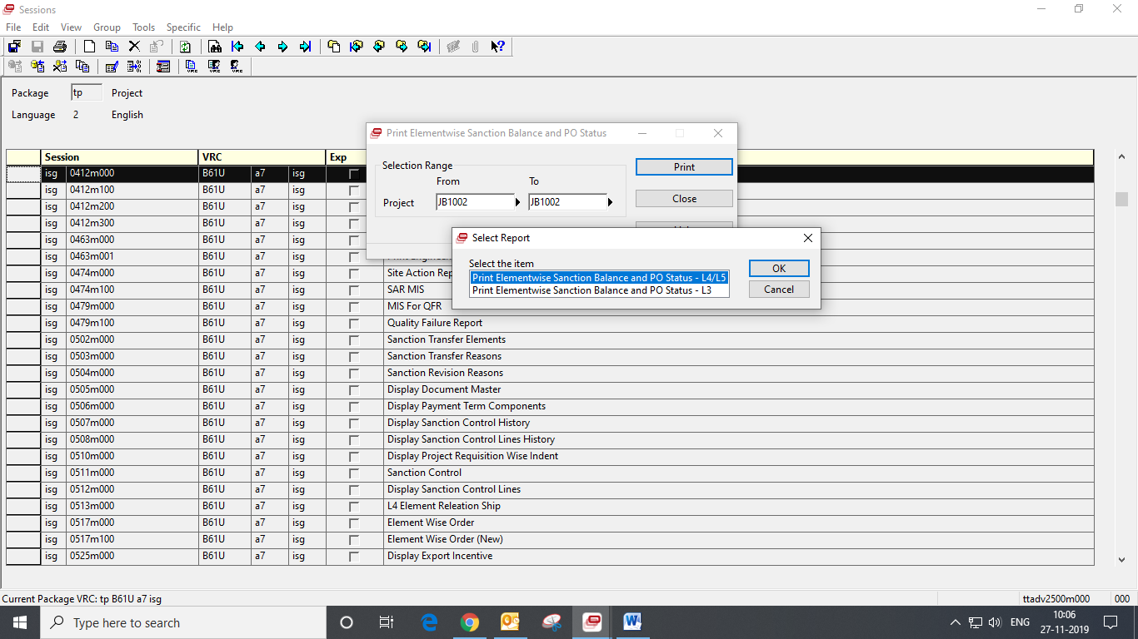

1. Enter Device and Paper Type and check Preview. Then click Continue.
2. Click Yes.

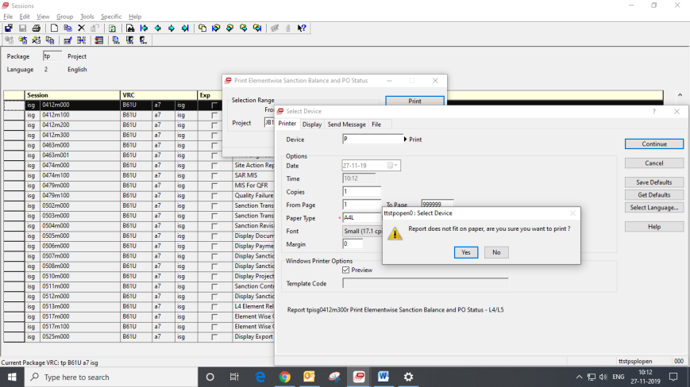

1. Report will get printed. 3 New Columns

added

